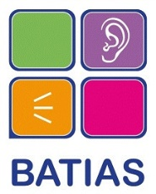
BATIAS Advocacy Spot Purchase Service Agreement
Please complete the following table and return to batias.grays@batias.com before date service required to confirm funding for Advocacy Spot Purchase has been agreed. We cannot finalise arrangements until confirmation has been received.
Name of professional making request and role:
Team/department:
Email address:
Phone numbers:
Are you authorised to make this request?
If you are not authorised please include name and contact details of person authorising this request:
Organisation requesting service:
Details of service requested:
Date/s service required:
Name and contact details for service user:
Agreed hourly rate for advocacy:
Additional travel, car parking and other expenses agreed:
Payment Process: Purchase Order Number and/or other information to quoted in our invoice:
Additional information:
Please sign to confirm you have authority to make this request and agree that stated hourly rate and expenses will be paid to BATIAS on receipt of invoice:
Date:

For BATIAS office use:
Date request received:…………………………………………………………………
BATIAS staff member responsible:……………………………………………………
Cost per advocacy hour:………………………………………………………………
Additional expenses agreed:…………………………………………………………

